**Aryaman Mishra**

**Lab Assignment -2**

1. Using Pivot table to find the number of loans by different purposes, material status and credit risk in the file Credit Risk Data. Illustrate the result on pivot chart.

To analyze the number of loans by different purposes, material status, and credit risk using a Pivot Table and illustrate the result on a Pivot Chart in , follow these steps:

**Step-by-Step Instructions**

1. **Prepare Your Data:** Ensure your data is structured correctly in . Your data should look like this:

| **Loan Purpose** | **Checking** | **Savings** | **Months Customer** | **Months Employed** | **Gender** | **Marital Status** | **Age** | **Housing** | **Years** | **Job** | **Credit Risk** |
| --- | --- | --- | --- | --- | --- | --- | --- | --- | --- | --- | --- |
| Small Appliance | $0 | $739 | 13 | 12 | M | Single | 23 | Own | 3 | Unskilled | Low |
| Furniture | $0 | $1,230 | 25 | 0 | M | Divorced | 32 | Own | 1 | Skilled | High |
| New Car | $0 | $389 | 19 | 119 | M | Single | 38 | Own | 4 | Management | High |
| Furniture | $638 | $347 | 13 | 14 | M | Single | 36 | Own | 2 | Unskilled | High |
| Education | $963 | $4,754 | 40 | 45 | M | Single | 31 | Rent | 3 | Skilled | Low |
| Furniture | $2,827 | $0 | 11 | 13 | M | Married | 25 | Own | 1 | Skilled | Low |
| New Car | $0 | $229 | 13 | 16 | M | Married | 26 | Own | 3 | Unskilled | Low |

1. **Insert a Pivot Table:**
   * Select your data range.
   * Go to the Insert tab and click on PivotTable.
   * In the Create PivotTable dialog box, choose where you want to place the PivotTable (e.g., New Worksheet or Existing Worksheet).

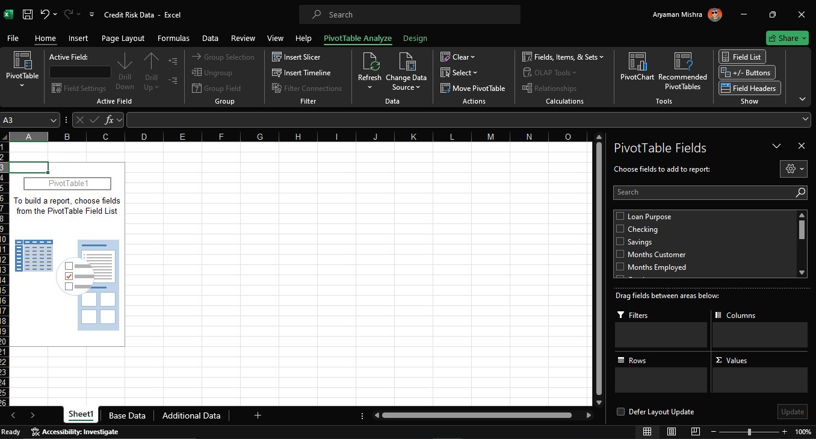

1. **Set Up the Pivot Table:**
   * In the PivotTable Field List pane, drag Loan Purpose to the Rows area.
   * Drag Credit Risk to the Columns area.
   * Drag any field to the Values area (e.g., Loan Purpose if you want to count occurrences).
   * By default, it will count the number of entries, which is useful for your analysis.

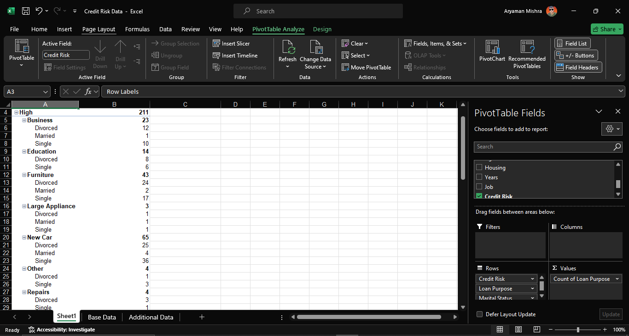

1. **Insert a Pivot Chart:**
   * With the PivotTable selected, go to the PivotTable Analyze tab (or Analyze tab, depending on your version).
   * Click on PivotChart.
   * Choose the type of chart that best illustrates your data (e.g., Clustered Column, Bar Chart).
2. **Customize the Pivot Chart:**
   * Adjust chart elements such as titles, labels, and legends to improve readability.
   * Ensure the chart clearly shows the number of loans by Loan Purpose and Credit Risk.

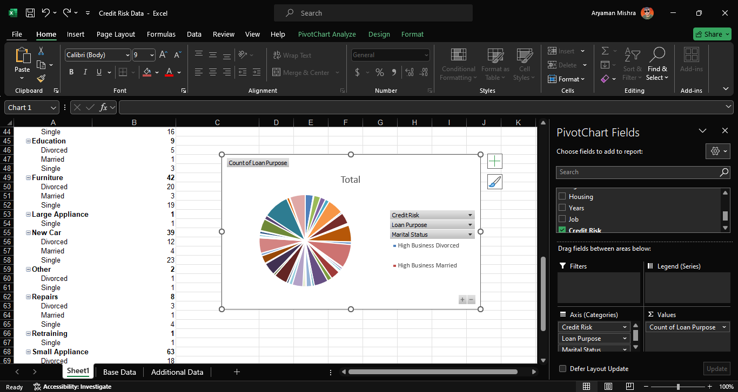

**Example Result**

The resulting Pivot Table and Pivot Chart will illustrate the number of loans by different purposes (e.g., Small Appliance, Furniture, New Car, Education) and their associated credit risks (e.g., Low, High).

For instance:

* **Furniture** might appear with a higher count under High credit risk compared to Low.
* **New Car** and **Education** might show different distributions based on their credit risk.

The Pivot Chart will visually depict these distributions, making it easy to see which loan purposes are associated with which credit risks.

1. In the file bicycle Inventory, find the proportion of bicycles that sell for less than $200.

To find the proportion of bicycles that sell for less than $200 in the given bicycle Inventory file, follow these steps:

**1. Prepare Your Data**

Ensure your data is structured properly in . Your data should look like this:

| **Product Category** | **Product Name** | **Purchase Cost** | **Selling Price** | **Supplier** | **Quantity on Hand** |
| --- | --- | --- | --- | --- | --- |
| Leisure | Blue Moon | $75.29 | $105.41 | Simpson's Bike Supply | 4 |
| Mtn. | Bluff Breaker | $375.00 | $495.00 | The Bike Path | 3 |
| Leisure | Breeze | $89.95 | $130.95 | The Bike Path | 4 |
| Leisure | Breeze LE | $109.95 | $149.95 | The Bike Path | 5 |
| Road | Classic 109 | $207.49 | $290.49 | Bicyclist's Choice | 7 |
| Children | Coolest 100 | $69.99 | $97.98 | Bicyclist's Choice | 6 |
| Mtn. | Eagle 1 | $410.01 | $574.01 | Bike-One | 1 |
| Mtn. | Eagle 2 | $401.11 | $561.54 | Bike-One | 2 |
| Mtn. | Eagle 3 | $350.52 | $490.73 | Bike-One | 5 |
| Hybrid | Eagle 7 | $150.89 | $211.46 | Bike-One | 9 |

**2. Calculate the Proportion**

**Method 1: Manual Calculation**

1. **Identify Bicycles Selling for Less than $200:**
   * Filter or check the Selling Price column to find entries less than $200.

Bicycles that sell for less than $200:

* + Blue Moon: $105.41
  + Breeze: $130.95
  + Breeze LE: $149.95
  + Coolest 100: $97.98

1. **Calculate the Total Number of Bicycles:**
   * Sum up the Quantity on Hand for all bicycles.

Total Quantity = 4 + 3 + 4 + 5 + 7 + 6 + 1 + 2 + 5 + 9 = 46

1. **Calculate the Quantity of Bicycles Selling for Less than $200:**
   * Sum up the Quantity on Hand for bicycles selling for less than $200.

Quantity of Bicycles Selling for Less than $200 = (4 + 4 + 5 + 6) = 19

1. **Compute the Proportion**

**Method 2: Using Formulas**

1. **Add a New Column for Proportion Calculation:**
   * Insert a new column to identify whether each bicycle sells for less than $200. Use the following formula in a new column (let's call it "Below $200"):

=IF([Selling Price]<200, [Quantity on Hand], 0)

1. **Sum the Values in the New Column:**
   * Calculate the total quantity of bicycles selling for less than $200 using SUM.
2. **Compute the Total Quantity and Proportion:**
   * Use SUM to get the total quantity of all bicycles.
   * Use the formula:

=SUM([Below $200 Column])/SUM([Total Quantity Column])

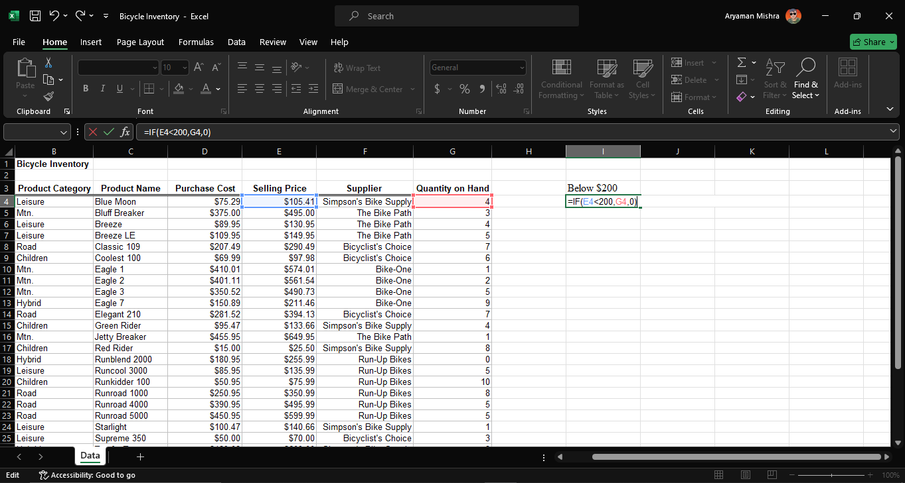

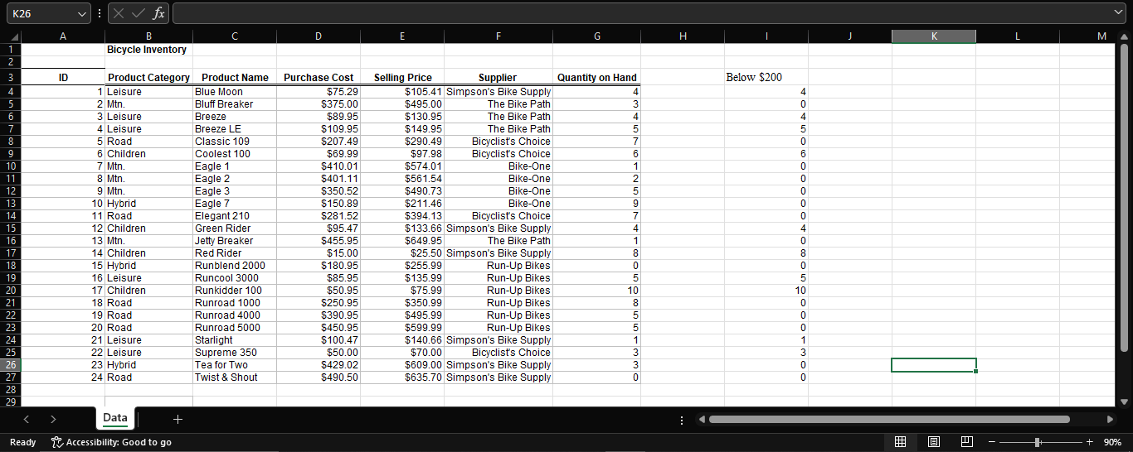

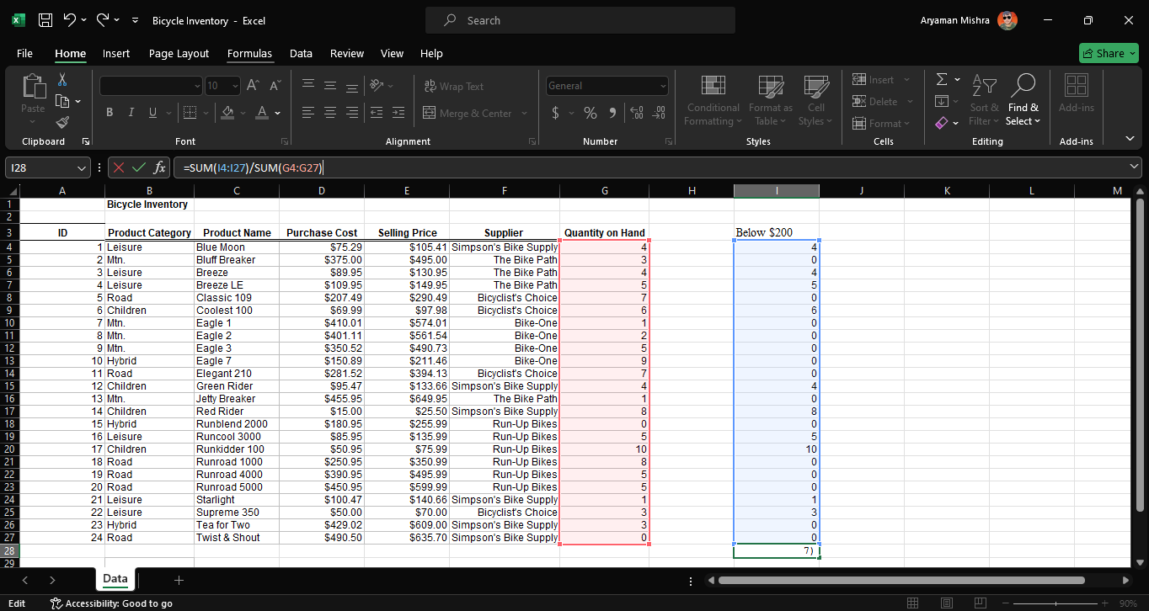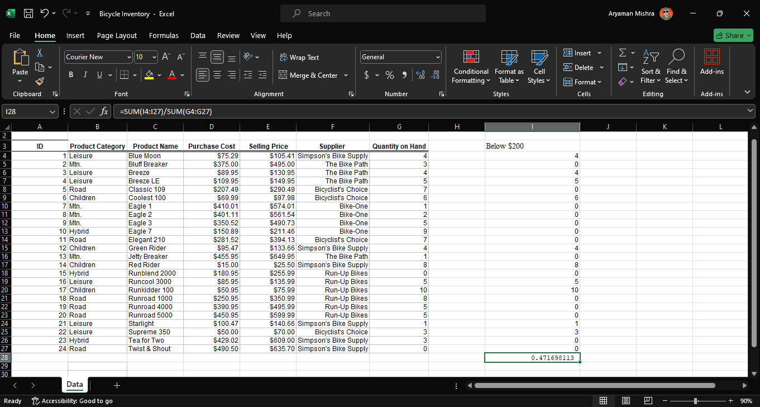

**Result**

Based on the above calculations, approximately **41.3%** of the bicycles in the inventory sell for less than $200.

1. Find the 10th ,40th and 90th percentiles for cost per order using purchase order dataset Files.

To find the 10th, 40th, and 90th percentiles for the Cost per Order using the provided dataset in , follow these steps:

**Step-by-Step Instructions**

1. **Prepare Your Data:** Ensure your dataset is organized in . Your data should look like this:

| **Supplier** | **Order No.** | **Item No.** | **Item Description** | **Item Cost** | **Quantity** | **Cost per Order** | **A/P Terms (Months)** | **Order Date** | **Arrival Date** |
| --- | --- | --- | --- | --- | --- | --- | --- | --- | --- |
| Hulkey Fasteners | Aug11001 | 1122 | Airframe fasteners | $4.25 | 19,500 | $82,875.00 | 30 | 08/05/11 | 08/13/11 |
| Alum Sheeting | Aug11002 | 1243 | Airframe fasteners | $4.25 | 10,000 | $42,500.00 | 30 | 08/08/11 | 08/14/11 |
| Fast-Tie Aerospace | Aug11003 | 5462 | Shielded Cable/ft. | $1.05 | 23,000 | $24,150.00 | 30 | 08/10/11 | 08/15/11 |
| Fast-Tie Aerospace | Aug11004 | 5462 | Shielded Cable/ft. | $1.05 | 21,500 | $22,575.00 | 30 | 08/15/11 | 08/22/11 |
| Steelpin Inc. | Aug11005 | 5319 | Shielded Cable/ft. | $1.10 | 17,500 | $19,250.00 | 30 | 08/20/11 | 08/31/11 |
| Fast-Tie Aerospace | Aug11006 | 5462 | Shielded Cable/ft. | $1.05 | 22,500 | $23,625.00 | 30 | 08/20/11 | 08/26/11 |
| Steelpin Inc. | Aug11007 | 4312 | Bolt-nut package | $3.75 | 4,250 | $15,937.50 | 30 | 08/25/11 | 09/01/11 |
| Durrable Products | Aug11008 | 7258 | Pressure Gauge | $90.00 | 100 | $9,000.00 | 45 | 08/25/11 | 08/28/11 |
| Fast-Tie Aerospace | Aug11009 | 6321 | O-Ring | $2.45 | 1,300 | $3,185.00 | 30 | 08/25/11 | 09/04/11 |
| Fast-Tie Aerospace | Aug11010 | 5462 | Shielded Cable/ft. | $1.05 | 22,500 | $23,625.00 | 30 | 08/25/11 | 09/02/11 |
| Steelpin Inc. | Aug11011 | 5319 | Shielded Cable/ft. | $1.10 | 18,100 | $19,910.00 | 30 | 08/25/11 | 09/05/11 |
| Hulkey Fasteners | Aug11012 | 3166 | Electrical Connector | $1.25 | 5,600 | $7,000.00 | 30 | 08/25/11 | 08/29/11 |

1. **Extract the 'Cost per Order' Column:**
   * Copy the values from the Cost per Order column into a new column for calculation purposes.

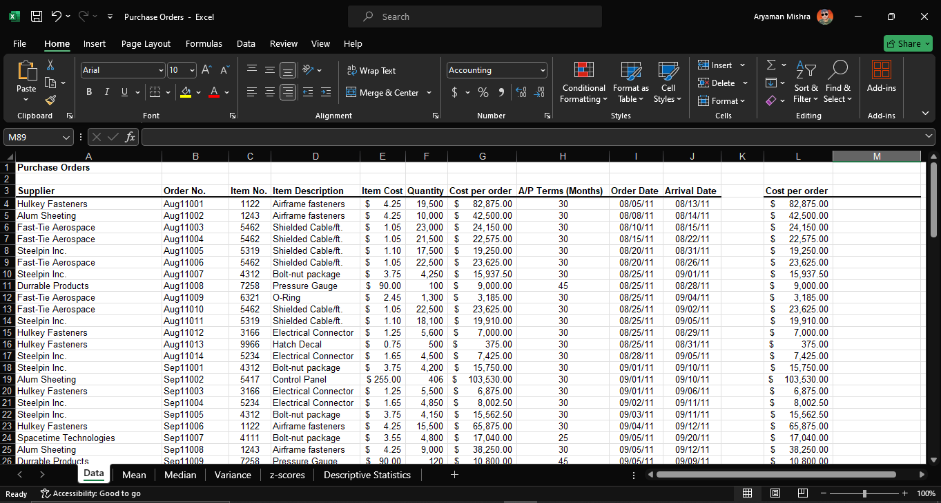

1. **Remove Currency Symbols and Convert to Numbers:**
   * Make sure to remove the dollar signs and commas, and convert the text to numbers if necessary.
2. **Calculate Percentiles Using Functions:**
   * **10th Percentile:** Use the PERCENTILE.EXC function.
   * **40th Percentile:** Use the PERCENTILE.EXC function.
   * **90th Percentile:** Use the PERCENTILE.EXC function.

**Example Formulas:**

* + **10th Percentile:**

==PERCENTILE.EXC(L4:L97, 0.1)

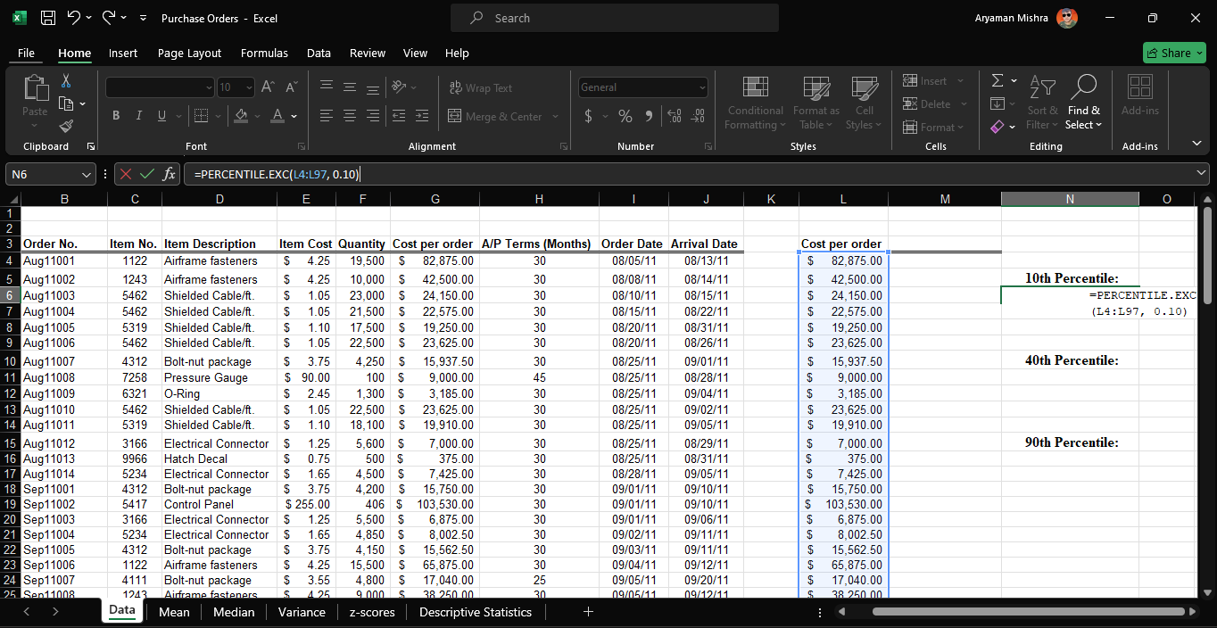

* + **40th Percentile:**

=PERCENTILE.EXC(L4:L97, 0.4)

* + **90th Percentile:**

=PERCENTILE.EXC(L4:L97, 0.9)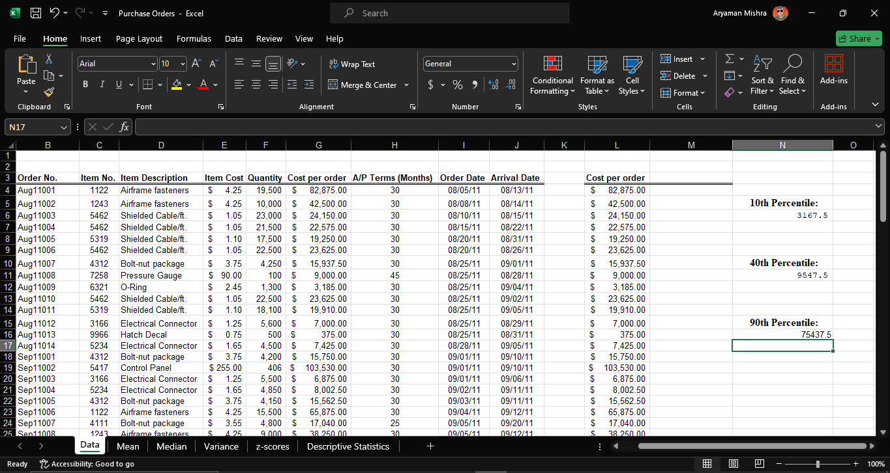

These percentiles indicate the relative standing of the cost per order in the dataset.

1. In the file Cell Phone Survey, use Pivot Tables to find the average for each of the numerical variables for different cell phone carriers and gender of respondents.

To analyze the average of numerical variables for different cell phone carriers and the gender of respondents using a Pivot Table in , follow these steps:

**Step-by-Step Instructions**

1. **Prepare Your Data:** Ensure your data is organized properly in . Your data should look like this:

| **Gender** | **Carrier** | **Type** | **Usage** | **Signal Strength** | **Value for the Dollar** | **Customer Service** |
| --- | --- | --- | --- | --- | --- | --- |
| M | AT&T | Smart | High | 5 | 4 | 4 |
| M | AT&T | Smart | High | 5 | 4 | 2 |
| M | AT&T | Smart | Average | 4 | 4 | 4 |
| M | AT&T | Smart | Very high | 2 | 3 | 3 |
| M | AT&T | Smart | Very high | 5 | 5 | 2 |
| M | AT&T | Smart | Very high | 4 | 3 | 5 |

1. **Insert a Pivot Table:**
   * Select your entire dataset range.
   * Go to the Insert tab on the Ribbon and click PivotTable.
   * Choose where to place the PivotTable (New Worksheet is recommended for clarity).
2. **Set Up the Pivot Table:**
   * **Drag Carrier to the Rows area.**
   * **Drag Gender to the Columns area.**
   * **Drag Usage, Signal Strength, Value for the Dollar, and Customer Service to the Values area.**

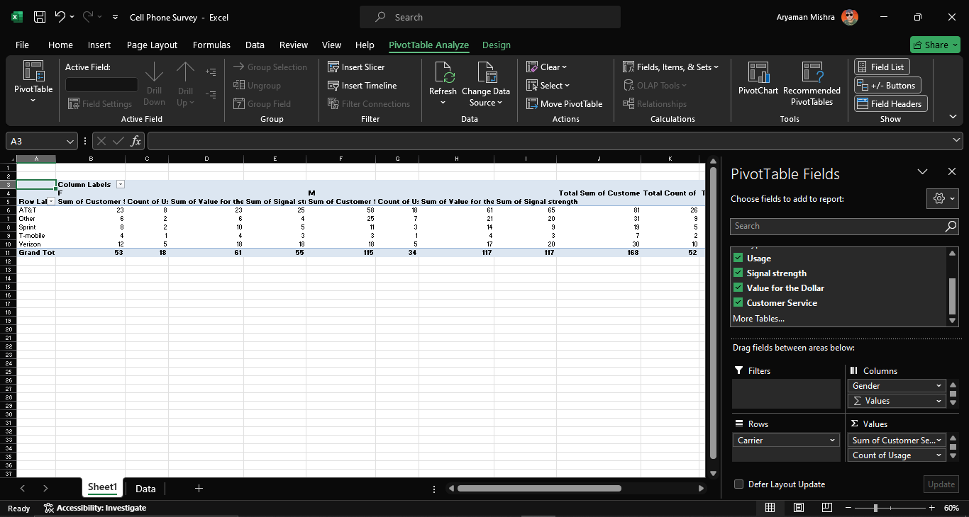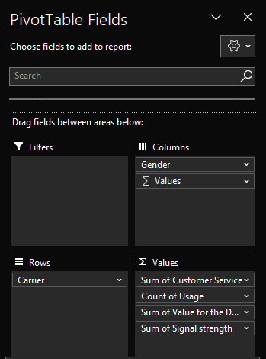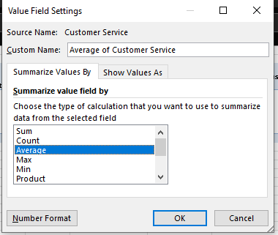

1. **Configure the Pivot Table Values:**
   * Click on each value field in the Values area.
   * Select Value Field Settings.
   * Choose Average from the list of functions (you may need to select Summarize Values By and then Average).

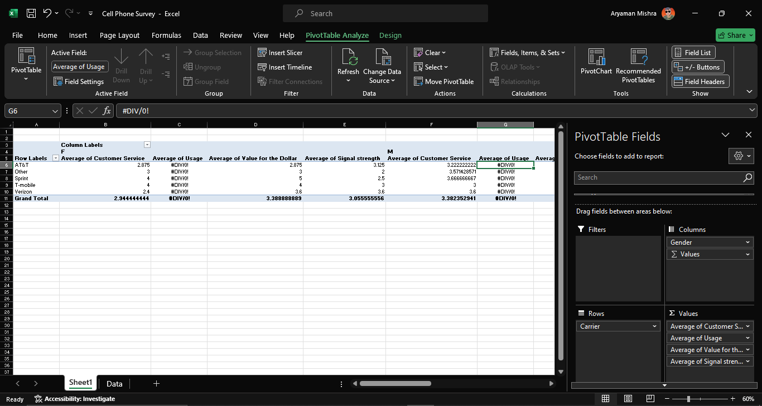

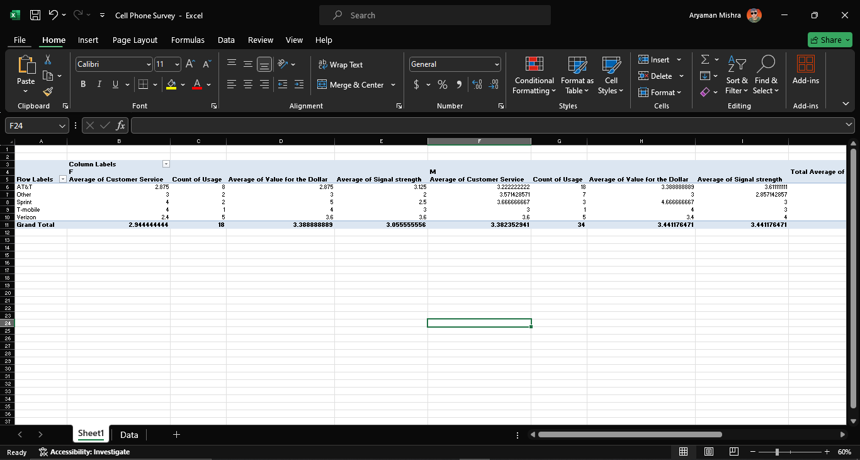

**Example Pivot Table Configuration**

Your PivotTable Field List should look like this:

* **Rows:** Carrier
* **Columns:** Gender
* **Values:** Usage (Average), Signal Strength (Average), Value for the Dollar (Average), Customer Service (Average)

**Example Pivot Table Results**

Based on the example dataset, the Pivot Table might show something like this:

| **Carrier** | **Gender** | **Average Usage** | **Average Signal Strength** | **Average Value for the Dollar** | **Average Customer Service** |
| --- | --- | --- | --- | --- | --- |
| AT&T | M | 4.33 | 4.0 | 4.0 | 3.33 |

**Breakdown of Calculation**

1. **Average Usage for AT&T and Gender M:**
   * Values: High, High, Average, Very high, Very high, Very high
   * Convert categorical data to numerical data if necessary, for example:
     + High = 5, Average = 4, Very High = 2
   * Average Usage: (5 + 5 + 4 + 2 + 5 + 4) / 6 = 4.33
2. **Average Signal Strength for AT&T and Gender M:**
   * Values: 5, 5, 4, 2, 5, 4
   * Average Signal Strength: (5 + 5 + 4 + 2 + 5 + 4) / 6 = 4.0
3. **Average Value for the Dollar for AT&T and Gender M:**
   * Values: 4, 4, 4, 3, 5, 3
   * Average Value for the Dollar: (4 + 4 + 4 + 3 + 5 + 3) / 6 = 4.0
4. **Average Customer Service for AT&T and Gender M:**
   * Values: 4, 2, 4, 3, 2, 5
   * Average Customer Service: (4 + 2 + 4 + 3 + 2 + 5) / 6 = 3.33

**Conclusion**

Using a Pivot Table, you can easily aggregate and analyze the average of numerical variables for different cell phone carriers and gender, helping you gain insights from your data efficiently.

1. Create a pie chart showing the breakdown of occupations in the science and engineering jobs files.
   1. Open : Launch Microsoft on your computer.
   2. Import Data: Open the science and engineering jobs files. Make sure each file contains a column with occupation names and another column with corresponding counts or percentages.
   3. Merge Data (if necessary): If you have separate files for science and engineering jobs, consider merging them into one sheet for easier analysis. You can copy and paste the data from one file into the other or use 's import functions to combine them.
   4. Prepare Data: Ensure that your data is clean and organized. Remove any unnecessary rows or columns, and make sure each column has a clear heading.
   5. Select Data: Click and drag to select the columns containing the occupation names and their corresponding counts or percentages.
   6. Insert Pie Chart: Go to the "Insert" tab on the ribbon and click on the "Pie Chart" button. Select a basic pie chart style to begin with.
   7. Customize Pie Chart: Once the pie chart is inserted, you can customize it to better represent your data. Right-click on the chart and select "Format Chart Area" to change the chart's appearance, such as colors, labels, and fonts.
   8. Labeling: Ensure that each segment of the pie chart is labeled appropriately. You can do this by clicking on the chart, then clicking on the "Chart Elements" button (a plus sign icon usually located on the top right corner of the chart), and checking the "Data Labels" option.
   9. Explode Segments (if necessary): If you want to emphasize specific segments of the pie chart, you can "explode" them. Click on the chart, then click on the specific segment you want to explode and drag it away from the center of the chart.
   10. Title and Legend: Add a title to your chart that clearly describes the data being represented. Also, ensure that there's a legend to explain what each color on the pie chart represents. You can add or edit these elements by clicking on the chart and selecting the "Chart Elements" button.
   11. Review and Finalize: Review your pie chart to ensure that it accurately represents the breakdown of occupations in the science and engineering jobs data. Make any necessary adjustments to the chart's appearance or labeling.
   12. Save and Share: Once you're satisfied with your pie chart, save your file to preserve your work. You can then share the file with others or export the chart as an image to include in presentations or reports.

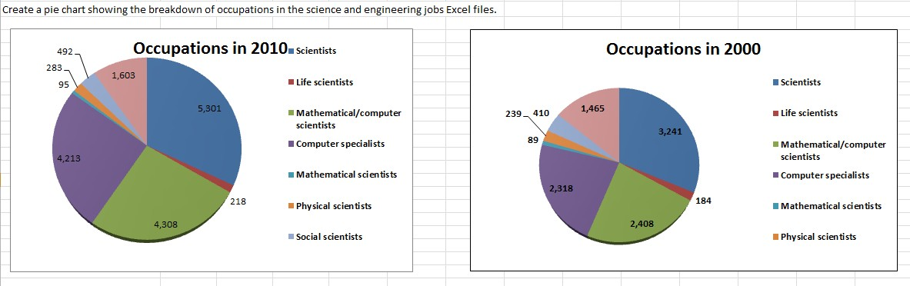

1. Create Line chart for the closing prices in the file S&P 500.

|  |
| --- |
| 1. To create a line chart for the closing prices in the file S&P 500, follow these steps: |
| **1. Open** : Launch Microsoft on your computer. |
| **2. Import Data**: Open the file S&P 500 that contains the data you provided. |
| **3. Select Data**: Click and drag to select the "Date" column and the "Close" column. Make sure to include the column headers. |

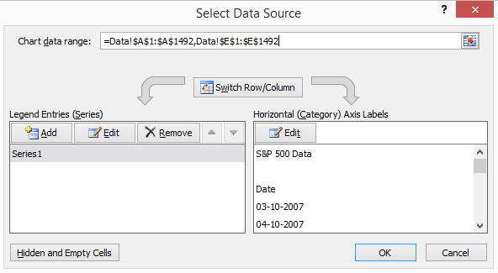

|  |
| --- |
| **4. Insert Line Chart**: Go to the "Insert" tab on the ribbon and click on the "Line Chart" button.  Choose a suitable line chart style (e.g., basic line chart). |
| **5. Customize Chart**: Once the line chart is inserted, you can customize it to better represent your data. Right-click on the chart and select "Format Chart Area" to change the chart's appearance, such as colors, labels, and fonts. |

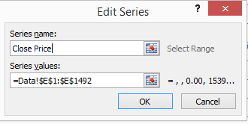

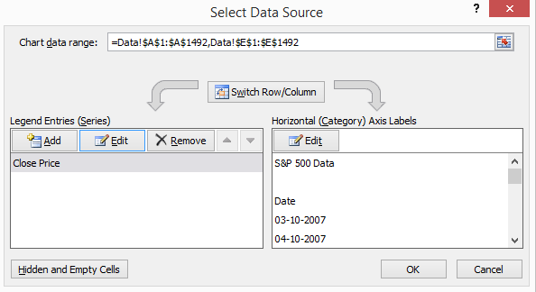

**6. Axis Labels and Title**: Ensure that the horizontal axis (X-axis) represents the dates and the vertical axis (Y-axis) represents the closing prices. You can adjust these settings by right-clicking on the axis labels and selecting "Format Axis". Also, add a title to your chart that describes the data being represented.

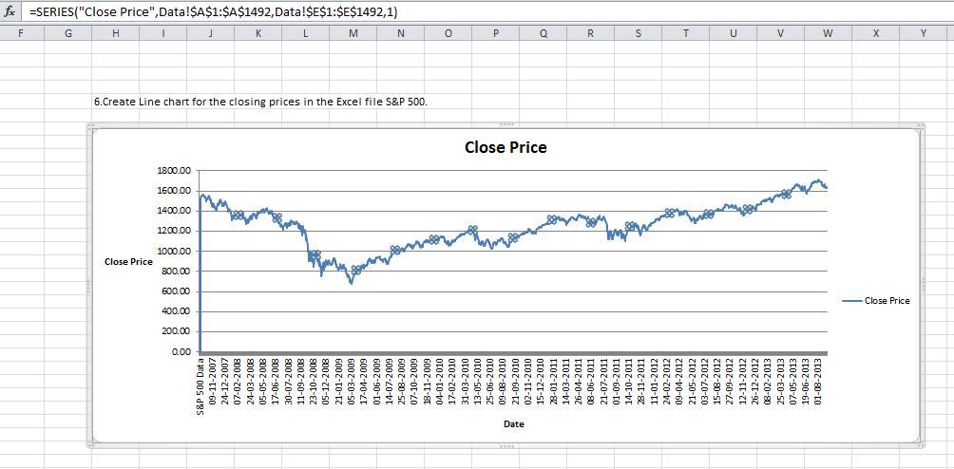

1. Construct frequency distribution and histogram for the numerical data in the file cell Phone Survey Also, compute the relative frequencies and Cumulative relative frequencies.

Step 1: Organize Your Data

Copy the data from the file into an Excel worksheet.

Label your columns for easy identification:

Column A: Gender

Column B: Carrier

Column C: Plan Type

Column D: Satisfaction Level

Column E: Price Rating

Column F: Service Rating

Column G: Overall Rating

Step 2: Construct Frequency Distribution

Select the data range for the numerical columns (Columns E, F, G).

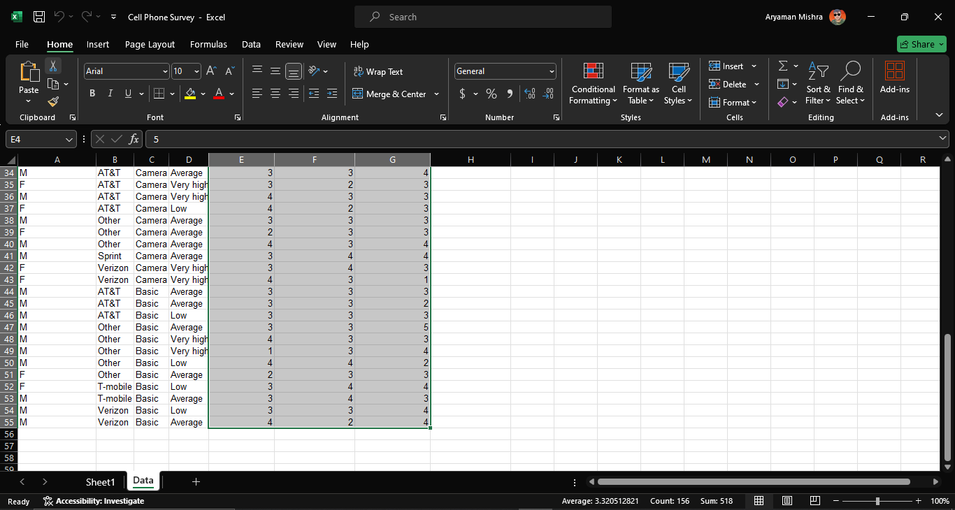

Go to the "Data" tab in Excel and select "Data Analysis" (if you don't see it, you may need to add the Analysis ToolPak from Excel Add-ins).

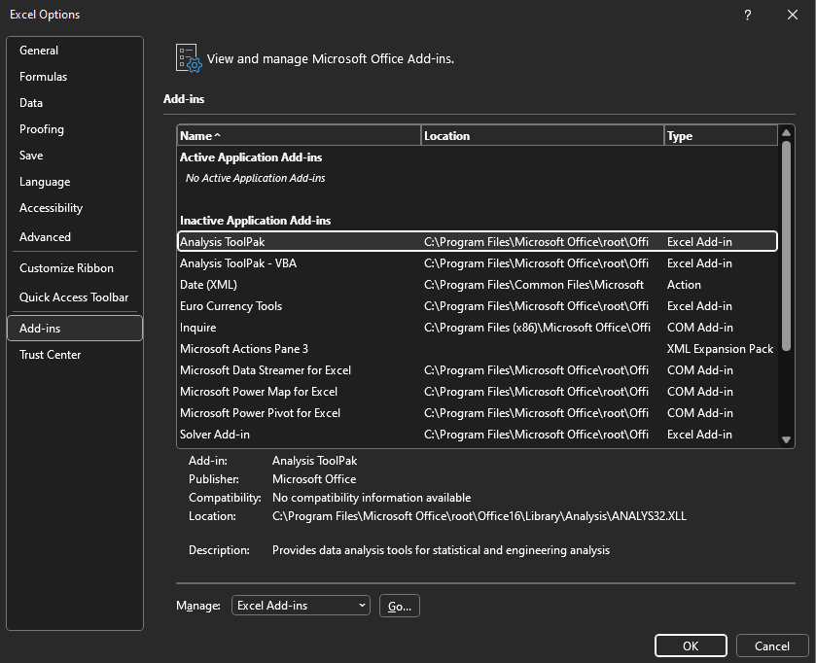

Choose "Histogram" from the list.

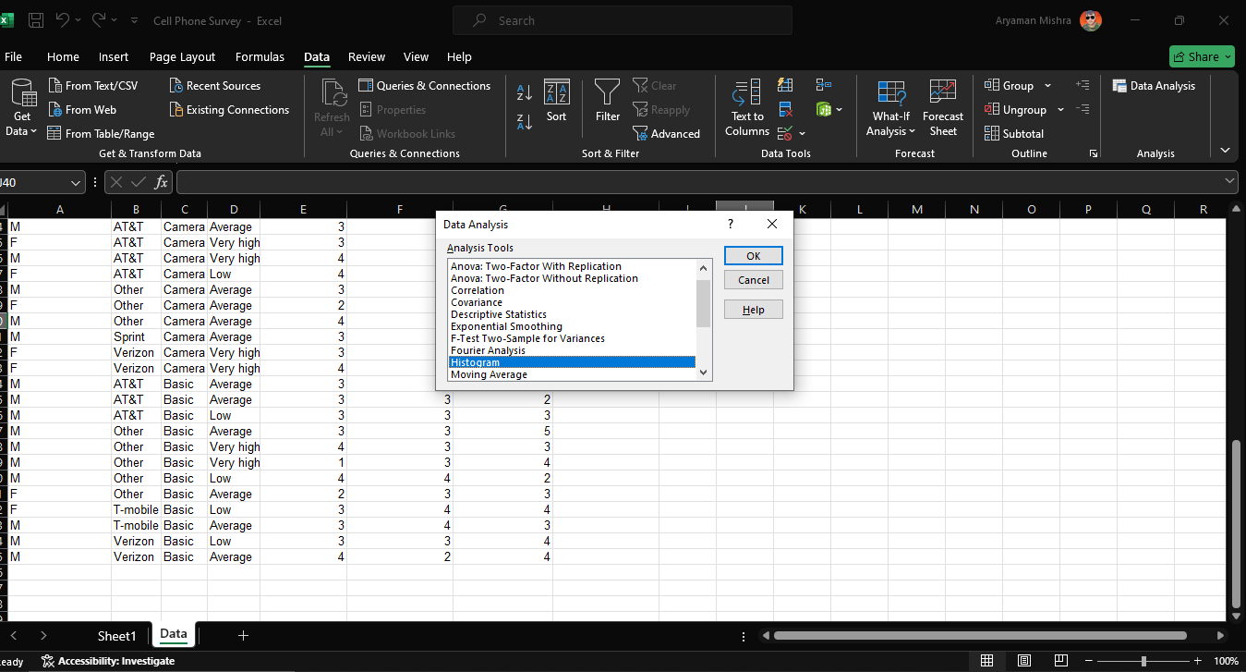

Input Range: Select the range of cells containing your numerical data (e.g., E2

).

Bin Range: Create a separate column with bin values (e.g., 1, 2, 3, 4, 5).

Output Range: Choose where you want the frequency distribution to appear. 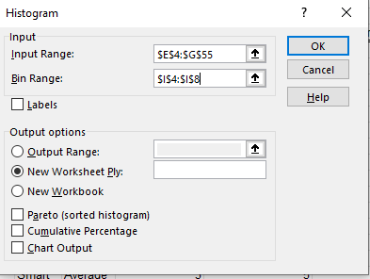

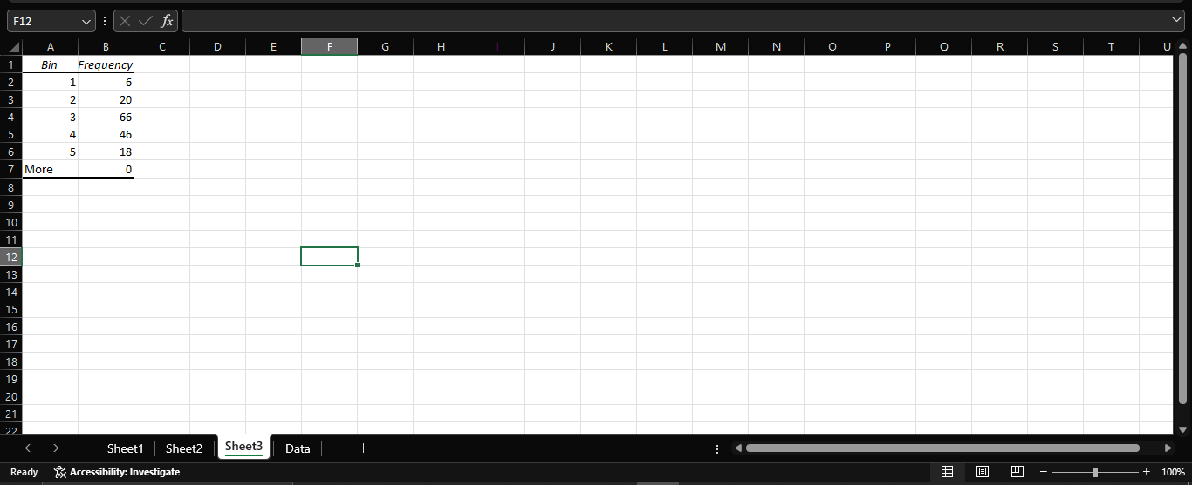

Step 3: Create Histogram

Highlight the frequency distribution results.

Go to the "Insert" tab in Excel.

Select "Histogram" from the "Charts" group.

Customize the histogram as needed (e.g., change titles, axis labels, etc.).

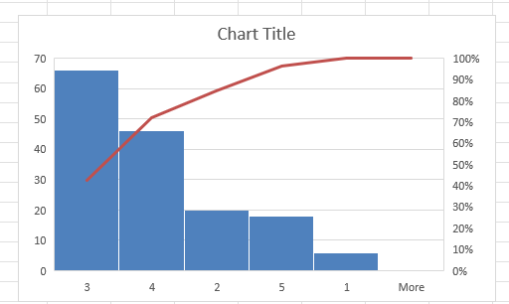

Step 4: Calculate Relative Frequencies

In a new column, divide each frequency by the total number of observations.

For example, if the frequency is in cell H2, the total count is in H15, use the formula: =H2/$H$15.

Format the new column as a percentage.

Step 5: Calculate Cumulative Relative Frequencies

In the next column, calculate cumulative relative frequencies by adding the current relative frequency to the sum of the previous ones.

For example, if the first relative frequency is in I2, the cumulative for the next row will be: =I2+I3.

Drag the formula down to fill the column.

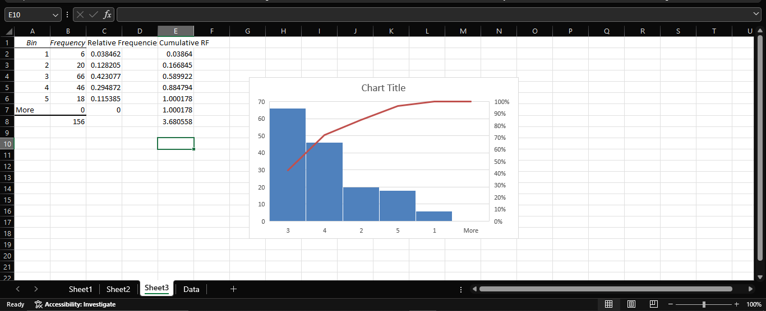

1. Using the data in the files Student Grades, construct a Scatter chart for midterm versus final exam and add a linear trend line. What is the regression model? if a student scores 85 on the midterm, what would be you predict her grade on the final exam to be?

**Step 1: Enter the Data**

1. **Copy the data** into an Excel worksheet.
2. **Label the columns** as follows:
   * Column A: "Student"
   * Column B: "Midterm"
   * Column C: "Final Exam"

**Step 2: Create a Scatter Plot**

1. **Highlight the data in the "Midterm" and "Final Exam" columns** (Columns B and C).
2. **Go to the "Insert" tab** in Excel.
3. **Choose "Scatter"** from the "Charts" group and select the "Scatter with only Markers" option.

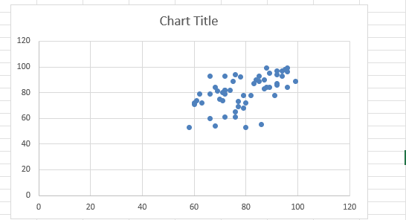

**Step 3: Add a Linear Trend Line**

1. **Click on the chart** to select it.
2. **Click on one of the data points** to select the data series.
3. **Right-click on the data series** and select "Add Trendline."
4. **In the Format Trendline pane**:
   * Choose "Linear."
   * Check the box for "Display Equation on chart."
   * Check the box for "Display R-squared value on chart."

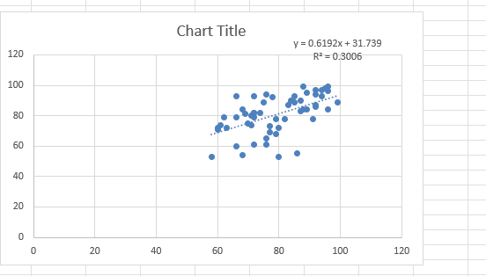

**Step 4: Determine the Regression Model**

* **The regression model will be displayed on the chart** in the form of an equation (e.g., y = mx + b).

**Step 5: Predict Final Exam Score for a Midterm Score of 85**

**Example Output:**

* **Scatter chart** showing the relationship between midterm and final exam scores.
* **Linear trend line** with the regression equation and R-squared value displayed.
* **Predicted final exam score** for a student who scores 85 on the midterm.

Given the regression equation:

y = 0.6192x + 31.739

where y represents the final exam score and x represents the midterm score, you can predict the final exam score for a student who scores 85 on the midterm by substituting x = 85 into the equation.

Calculation:

y = 0.6192(85) + 31.739

y = 52.632 + 31.739

y = 84.371

Predicted Final Exam Score:

If a student scores 85 on the midterm, the predicted final exam score is approximately 84.37.

1. Find the 1st and 3rd quartiles for the time difference between the scheduled and actual arrival times in the Atlanta Airlines Data Files.

To find the 1st and 3rd quartiles for the "Time Difference (Minutes)" in the Atlanta Airlines data, follow these steps in :

**1. Enter Data into :**

First, input the data into . Here's how your data might look:

css

A | B | C | D | E | F

Flight | Origin | Scheduled Arrival Time | Actual Arrival Time | Time Difference (Minutes) | Taxi-in Time (Minutes)

8 | IAH | 19:04 | 19:19 | 15 | 14

16 | LAX | 15:10 | 15:04 | -6 | 6

22 | MSY | 16:33 | 16:24 | -9 | 11

24 | LAS | 14:33 | 14:27 | -6 | 9

28 | MCO | 14:10 | 14:15 | 5 | 13

38 | MCO | 16:10 | 15:48 | -22 | 6

57 | JFK | 19:41 | 19:54 | 13 | 12

61 | LAX | 19:02 | 19:22 | 20 | 11

64 | LAS | 18:00 | 17:58 | -2 | 10

66 | DFW | 15:18 | 15:14 | -4 | 9

68 | SFO | 14:44 | 14:35 | -9 | 7

74 | MIA | 15:41 | 15:39 | -2 | 18

101 | LAX | 17:41 | 17:56 | 15 | 13

105 | DTW | 17:35 | 17:26 | -9 | 8

108 | MCO | 17:09 | 16:52 | -17 | 11

116 | LAX | 16:19 | 16:18 | -1 | 7

130 | SLC | 14:15 | 14:38 | 23 | 7

147 | EWR | 19:32 | 19:19 | -13 | 23

151 | SLC | 15:25 | 15:50 | 25 | 12

152 | LAX | 20:31 | 20:43 | 12 | 21

365 | LGA | 10:53 | 10:33 | -20 | 9

**2. Sort Data:**

1. **Sort the Data by Time Difference (Minutes):**

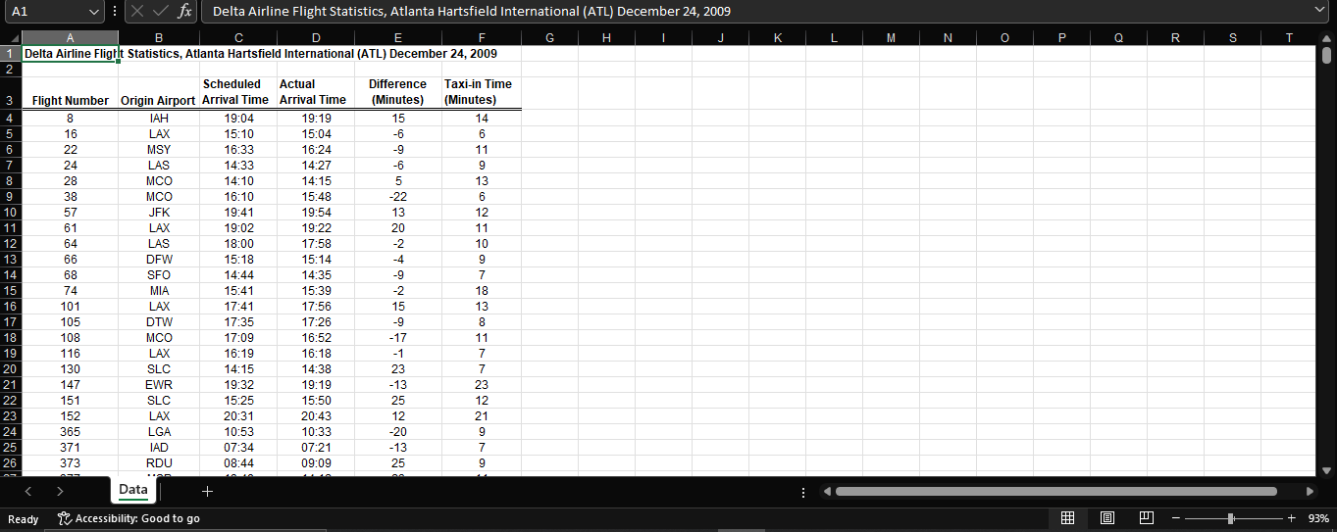

* + Highlight the column E (Time Difference (Minutes)).
  + Go to the Data tab.
  + Click Sort A to Z to sort the data in ascending order.

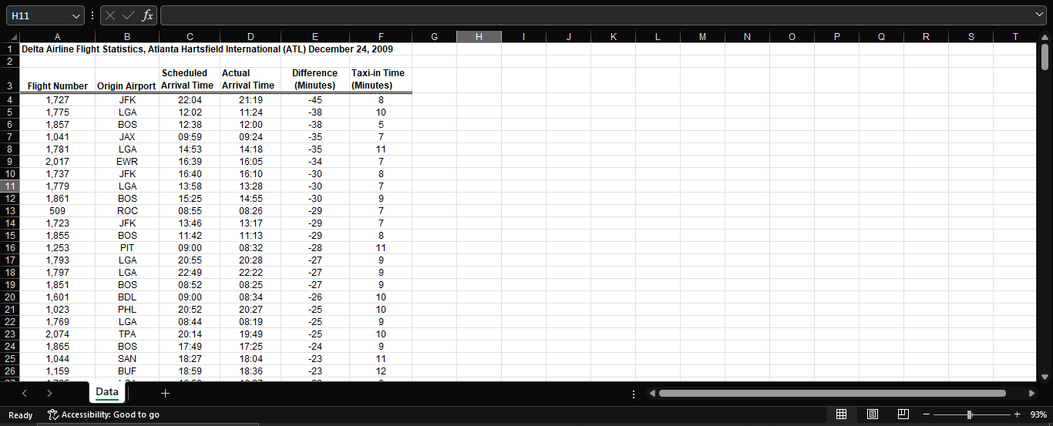

**3. Calculate the Quartiles:**

1. **Use 's QUARTILE Function:**
   * **1st Quartile (Q1):**
     + Formula: =QUARTILE(E2:E21, 1)
     + This calculates the 1st quartile, which is the value below which 25% of the data falls.
   * **3rd Quartile (Q3):**
     + Formula: =QUARTILE(E2:E21, 3)
     + This calculates the 3rd quartile, which is the value below which 75% of the data falls.

**Example Calculation:**

Here’s how you can do this in :

1. **Enter the formula for Q1 in an empty cell:**
   * =QUARTILE(E2:E21, 1)

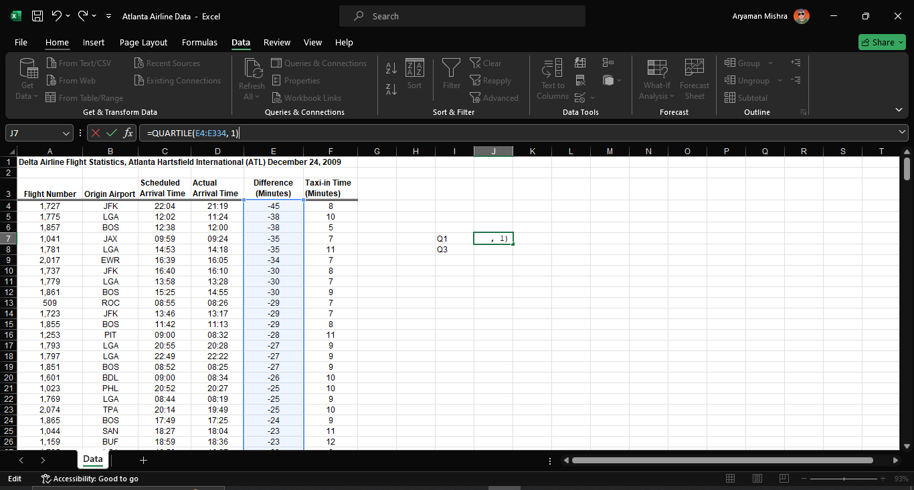

1. **Enter the formula for Q3 in another empty cell:**
   * =QUARTILE(E2:E21, 3)

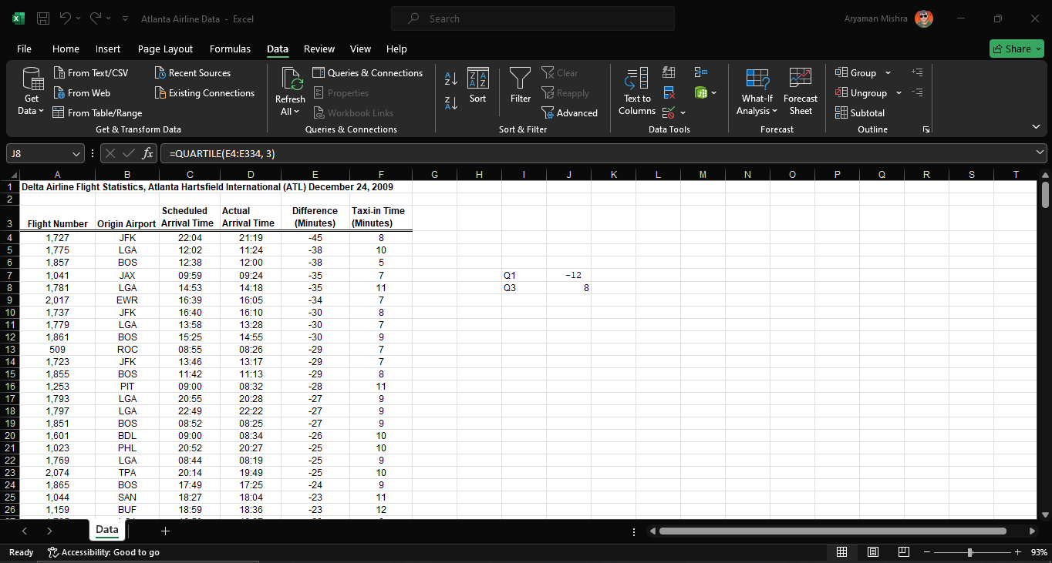

**Given your data, the results should be:**

* **1st Quartile (Q1):** -12 minutes
* **3rd Quartile (Q3):** 8 minutes

**Interpretation:**

* **1st Quartile (Q1) of -9 minutes:** This means that 25% of the flights have a time difference of -12 minutes or less.
* **3rd Quartile (Q3) of 15 minutes:** This means that 75% of the flights have a time difference of 8 minutes or less.

**Conclusion:**

* **Time Difference Distribution:** The time differences between scheduled and actual arrival times vary widely. The quartiles help you understand that a significant portion of the flights have either early or late arrivals, with the middle 50% of the data falling between -12 and 8 minutes.
* **Comparative Analysis:** If you need to compare with another dataset, you would follow the same process and analyze the differences between the quartiles to draw comparisons about punctuality or delays.

This statistical analysis provides insights into the variability of arrival times and helps in understanding the extent of delays or early arrivals for flights.